MAKE SURE YOUR exploRers ARE HEARD…
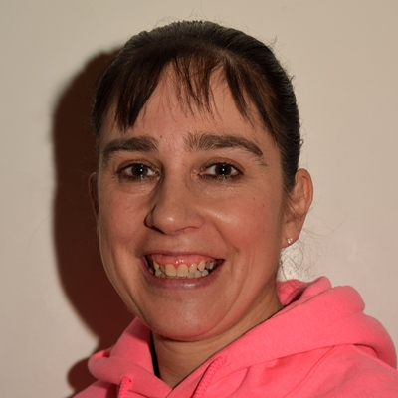
tell us what you think about explorers…
Information for leaders
Thank you very much for fitting our activity into your programme. This should take about 20 to 30 minutes.
We would be grateful if you could collate the results (or ask a young person to) either using the enclosed sheet or in your own format (appreciate if you have a large section then collating it in another way that’s easy for you).
Please photo, scan and email the results to hq@norfolkscouts.org.uk or post to County Office, Eaton Vale, Church Lane, Eaton, Norwich, NR4 6NN by 6 October 2017.

Please print one page per Explorer to complete.

This can then be used to start a unit discussion on the possibilities for young people in Scouting when they turn 18.

Thank you very much for your time and any questions please do not hesitate to get in touch with one of us.

Jane Warden,  DCC Programme  dccprogramme@gmail.com | Dom Belcher,  County Youth Commissioner d.belcher@norfolkscouts.org.uk

Introduction
Hello Section Leaders
Over the next few months my team will be pulling together our County Strategic Plan which we will use to help us to guide the development of Scouting locally of the next few years.
It will help us to shape the support that is available and help to make decisions in a joined-up way that best meet the interests of our Young People and help you as leaders to provide great programmes
It’s important that we get information from everyone involved in Scouting to find out what is important to people, what is special about Scouting and how we can change if it is needed.
Your help by completing the task in this pack with your Young People will really help a long way to building a picture of Norfolk Scouting today.
Thanks
Matthew
Matthew Burrell, County Commissioner (Norfolk)
Think hard about what you do at Explorers and have a go at filling in this wheel! Your leaders will then put all your ideas together and send them to me. Thanks for helping me find out more about your Scouting.
Dom Belcher, County Youth Commissioner

Two things I love about Explorers
Two things I don’t like about Explorers

When you are old enough, do you want to move up to Network/Leadership?
Anything else you would like to say about Beavers?

Information collation form
2 THINGS YOU LIKE…
2 THINGS YOU DISLIKE…
ARE YOU GOING TO MOVE UP…
ANY OTHER FEEDBACK….

From: Name of Group/Section: ………………………………………….
Leaders name and email address ………………………………………..

