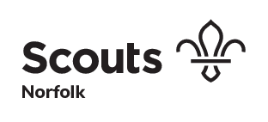

**Group and Occasional Badge Guidelines**

Respective policy: Policy, Organisation and Rules – Chapter 10 Uniform, Badges and Emblems

Version 2

Approved: 30 January 2017 by the Executive Committee

Revised: August 2018 to include new Scout logo, approval not required

Review Date: 30 January 2019

Owner: County Commissioner

**District, Group, Unit or Network Identifying Badges**

District, Group, Unit and Network badges to be worn on the uniform or scarf must be approved by the County Commissioner before such badges are made.

This type of badge is design to be worn by members of the District, Group, Unit or Network indefinitely.

Changes to the badge design should be treated as a new request.

Detailed instructions relating to identifying badges can be found in [POR rule 10.26](http://scouts.org.uk/media/761095/Chapter-10-plusUniform.pdf).

**Occasional Badges**

Occasional badges can be worn on uniforms to mark anniversaries, special events or trips.

Detailed instructions relating to how long occasional badges can be worn can be found in [POR rule 10.33](http://scouts.org.uk/media/761095/Chapter-10-plusUniform.pdf).

Occasional badges must be approved by the County Commissioner before there are made.

A request letter with full details of the badge design and colours and a clear drawing indicating the size should be sent to the County Commissioner.

Ideally this should be via email to hq@norfolkscouts.org.uk

Sufficient time to get approval should be given to allow for any changes to design, it is recommended that at least 8 weeks notice is given.

It can then take at least an additional four weeks for badges to be manufactured.

**Design guide**

The following guidance is provided to support any application to help ensure that approval can be given.

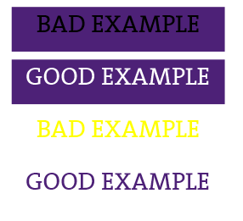Occasional badges must feature the Scout logo

Keep the design simple

Use upper case letters if possible

Use colours that complement each other so that the lettering is easily readable.

Use adventurous and exciting images

Use good contrast images

Follow Scout brand guidelines

**Using the Scout logo**

This is the preferred Scout logo, with adequate spacing.



The logo must always be one colour usually this will be Scout purple or black on a light background or white on a dark background.

Occasionally the logo could be in a Scout Secondary colour (see appendix for palette)

**Copyright**

**World Scout Badge**



The World Scout Badge is not permitted for use other than as a membership badge.

It is the property of the World Organisation of the Scout Movement and can only be used with express written permission.

**Other images**

Use of copyright and trademarks not owned by The Scout Association and without permission may be illegal. Always seek permission first.

Special permission will be required if the design is intended to incorporate the County Shield or any local Council borough arms etc. It is unlikely that permission will be given to use the County Shield on any Group badge.

**Image choice**

Images related to the event or occasion should ideally reflect the fun and adventure of Scouting.

**Size of badges**

The size is restricted to a maximum size as shown in the diagrams below, to include any bound edge.



**Appendix**

**Scout and Section Logo**

The Scout and Section logo files can be obtained from the Scout Brand Centre.

<https://scoutsbrand.org.uk/>

**Brand guidelines**

Further information about the Scout brand can be found on scouts.org.uk

https://docs.scoutsbrand.org.uk/guidelines.pdf